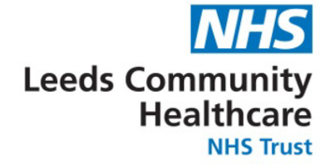

Leeds School Immunisation Service
Leeds Vaccination Centre
Park and Ride
Bobby Collins Way
Leeds
LS11 0EY
Email: leedsschoolcovidvaccinations@nhs.net
Tel: 0113 206 0593
COVID-19 vaccination for children aged 12 to 15 years of age consent form
Dear Parent,

We will soon be offering COVID-19 vaccinations in schools. This is in line with the government announcement on 13 September that all children aged 12 to 15 in England will be offered one dose of the Pfizer-BioNtech COVID-19 vaccination, following advice from the UK’s chief medical officers.

The purpose of the COVID-19 school age vaccination programme is to provide protection to the children who receive the vaccine, to reduce transmission of COVID-19 in the wider population and to reduce disruption to education.

Vaccinations will be undertaken by NHS staff.

This vaccination will be free of charge and our highest priority is making it easy for children to access one dose of the vaccine before the winter. During the vaccination delivery, we will have a range of measures in place to keep children safe from COVID-19.

Please indicate your intent by following the link below and completing the online consent form. By consenting you will be helping to play your part in reducing the risk of COVID-19 spreading.

How to give consent?

Please complete the online form AS SOON AS POSSIBLE as instructed below.

- Please follow this link to complete the online form: https://www.leedsimmunisations.co.uk/Forms/Covid
- This form is only to be completed for children between the age of 12-15.
- Enter a unique school code for your child’s school.

The code for The Grammar School at Leeds is ee108113 (please ensure you enter all letters and numbers)

We are coming into The Grammar School at Leeds on 28 September.

Please note - Even if you do not wish your child to receive the vaccination it is important to complete the “refusal section” of the consent form so we are aware of your wishes.

On the day your child may wish to provide their own consent. This sometimes occurs if a consent form has not been returned but your child still wishes to have the vaccine on the day of the session. Healthcare professionals from the vaccination programme will speak to your child and make every effort to contact you first. These professionals have expertise in vaccinating young people and will be responsible for assessing whether your child has enough understanding to give their own consent (this is called ‘Gillick competence’).

Your child will bring a confirmation slip home when they have received their vaccine.

Information about COVID-19 vaccines is available at: COVID-19 vaccination programme for young people: guidance for parents

If you experience any problems accessing the form or have any general questions, please telephone the COVID-19 Vaccination Team on 0113 206 0593 or email us at leedsschoolcovidvaccinations@nhs.net and one of our staff will be happy to help.

Yours faithfully,

Sam Prince

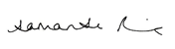

Executive Director of Operations
Leeds Community Healthcare NHS Trust

Help us get it right – if you have a complaint, concern, comment or compliment please contact patientexperience.leedsth@nhs.net or 0113 2066 261

